Can a happiness index really measure our wellbeing?
Can you really create a happiness index? As the government gets set to give it a go, see how the national wellbeing accounts score each country
• Get the data

Can a happiness index really measure our wellbeing?
As we've written before, there's more to life than GDP. And now, the government is poised to start measuring people's psychological and environmental wellbeing by creating its own happiness index.
The national statistician Jill Matheson has been asked to set about creating the index for the Office for Naitonal Statistics to start measuring, despite "nervousness" in Downing Street at the prospect of testing the national mood amid deep cuts and last week's riot in Westminster.
Countries such as France and Canada are looking at similar initiatives as governments around the world come under pressure to put less store on conventional economic measures of prosperity such as gross domestic product.
The New Economics Foundation has already started this process. A few years ago, it created the world Happy Planet Index, which compares various national indicators to rank the world's nations.
But its National Accounts of Wellbeing seems more akin to what the government is trying to create. Based on detailed survey responses across Europe, it scores our perceptions of work, social and personal life to come up with an indicator.
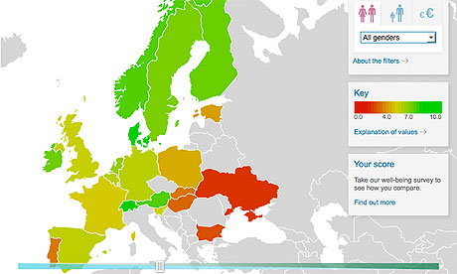
NEF wellbeing accounts explorer
There's more in Appendix two in the report, which adds:
To look at different aspects of well-being separately, but also to aggregate so as to look at overall personal well-being and overall social well-being, and allow the possibility for a single composite well-being indicator.
• To compare between countries, between different demographic groups, and over time.
• To compare, for a given country, the different aspects of well-being
National wellbeing


Download the data
• DATA: download the full spreadsheet

World government data
• Search the world's government with our gateway

Development and aid data
• Search the world's global development data with our gateway
Source: http://www.guardian.co.uk/news/datablog/2010/nov/15/happiness-index-wellbeing-nef

